# HAND SIGN RECOGNITION USING ML

Submitted in partial fulfillment of the requirements of the degree

**BACHELOR OF ENGINEERING IN COMPUTER ENGINEERING**

By

**1)Manoj Katkar VU1F1920019**

**2)Prathamesh Kokkula VU1F1920017**

**3)Anusha Vasala VU1F1920011**

**4)Tanvi Paradkar VU1F1920079**

Supervisor

**Prof. Dr. Mahavir Devamane**



**Department of Computer Engineering**

**Vasantdada Patil Pratishthan's College of Engineering & Visual Arts**

**Sion, Mumbai - 400 022**

**University of Mumbai**

**(AY 2021-22)**

# CERTIFICATE

This is to certify that the Mini Project entitled **“HAND SIGN RECOGNITION USING ML”** is a bonafide work of **Manoj Katkar (VU1F1920019), Prathamesh Kokkula (VU1F1920017), Anusha Vasala (VU1F1920011) , Tanvi Paradkar (VU1F1920079)**submitted to the University of Mumbai in partial fulfillment of the requirement for the award of the degree of **“Bachelor of Engineering”** in **“Computer Engineering” .**

### (Prof. Dr.Mahavir Devamane)

### Supervisor

### (Dr. Mahavir Devamane) (Dr. Alam N Shaikh)

**Head of Department Principal**

### INSTITUTE VISION & MISSION

## VISION:

To provide an environment to explore, encourage and educate students by facilitating innovative research, entrepreneurship, opportunities and employability to achieve professional goals.

The following strategic characteristics and aspirations enable the college to realize its vision.

## MISSION:

1. To provide facilities in the area of research and development.
2. To initiate the collaboration with industries and academic institutions in terms of project and internship.
3. To build up appropriate moral and ethical skills, to promote holistic development of students through various academic, social and cultural activities.
4. To develop leadership and to sharpen the students' skills by providing them opportunities for working in an innovative and interactive environment.
5. To kindle the zeal among the students and promote their quest for academic excellence.
6. To strengthen industry academic interaction to bridge the gap between theory and practice.
7. To recruit, retain and enable a diverse community of exceptional faculty and students.
8. To mould the students into competent professionals to foster economic development to meet the societal needs globally.

# COMPUTER ENGINEERING DEPARTMENT

## VISION:

To inculcate skills for overall development of students to be a leader in the world of computer engineering and contribute in favor of society.

## MISSION:

1. To provide students with a fundamental knowledge of theory, practical and problem solving skills with an exposure to emerging technologies.
2. Provide a platform for overall growth and adapting to challenges in rapidly changing technology.
3. To produce globally competent computer professionals with moral values and leadership abilities for sustainable development of the society.

# PROGRAM EDUCATIONAL OBJECTIVES (PEO's)

1. To create graduates with sound fundamental knowledge of computer engineering & enhance their skill set towards emerging technologies.
2. To inculcate the skills among students to formulate, analyze and propose the solutions to engineering problems.
3. To make the students aware of the professional ethics of the software industry.
4. To motivate the students for life-long self-learning.

**PROGRAM SPECIFIC OUTCOMES (PSOs)**

1. Graduates of the programme will be able to provide effective and efficient real time solutions using practical knowledge in the Computer Engineering domain.
2. Graduates of the programme will be able to use engineering practices, strategies and tactics for the development, operation and maintenance of software system

# Mini Project Approval

This Mini Project entitled **“Hand Sign Recognition using ML”** by **Manoj Katkar (VU1F1920019), Prathamesh Kokkula (VU1F1920017), Anusha Vasala (VU1F1920011), Tanvi Paradkar (VU1F1920079)** is approved for the degree of **Bachelor of Engineering** in **Computer Engineering.**

## Examiners

**1………………………………………**

(Internal Examiner Name & Sign)

### 2…………………………………………

(External Examiner name & Sign)

Date:

Place:

# CONTENTS

# Abstract vii

### Acknowledgments viii

**List of Figures ix**

**List of Abbreviations ix**

### Introduction 10-11

* 1. Introduction 9
  2. Motivation 10
  3. Problem Statement & Objectives 11

### Literature Survey 12-15

* 1. Survey of Existing System 12
  2. Limitation Existing system or research gap 14
  3. Mini Project Contribution 15

### Proposed System (eg New Approach of Data Summarization) 16-24

* 1. Introduction 16
  2. Architecture/Framework 17
  3. Model and Process Design 19
  4. Details of Hardware & Software 21
  5. Experiment and Results 22
  6. Ethical Issues 24
  7. Conclusion and Future work. 25

### References 26

### 4 Annexure

### 4.1 Published Paper /Camera Ready Paper/ Business pitch/proof of concept

### Abstract

# A hand gesture recognition system was developed to capture the hand gestures being performed by the user and to control a computer system based on the incoming information. Many of the existing systems in literature have implemented gesture recognition using only spatial modeling i.e. recognition of a single gesture and not temporal modeling i.e. recognition of motion of gestures. Also, the existing systems have not been implemented in real time, they use a pre- captured image as an input for gesture recognition.

# To overcome these existing problems a new architecture has been developed which aims to design a vision-based hand gesture recognition system with a high correct detection rate along with a high-performance criterion, which can work in a real time HCI system without having any of the mentioned strict limitations (gloves, uniform background etc.) on the user environment.

# Our Application is for Dumb and Deaf people. Normal people cannot understand the sign language used by Dumb and Deaf people, so for communicating with these kinds of people, Our Application will be useful as it will provide an interface for communication. If he /she wants to convey a message they need to use standardized sign language and the application smartly recognizes it and prints it, making our job simpler.

**Acknowledgments**

I would like to express my special thanks to my teacher **Prof. Dr.Mahavir Devamane** as well as our principal **Dr. Alam Shaikh** gave us the golden opportunity to do this wonderful project on the topic “**Hand Sign Recognition using ML**”, which also helped me in doing a lot of Research and I came to know about so many new things. I am really thankful to them.

Secondly I would also like to thank my parents and friends who helped me a lot in finalizing this project within the local time frame.

**List of Abbreviations**

MAP = Mean Average Precision

ML = Machine Learning

CGI = Computer Generated Imagery

GUI = Graphical User Interface

HTML = Hypertext Markup Language

CSS = Cascading Style Sheet

RAM = Random Access Memory

SRS = Software Requirement Specification

SSD = Single Shot Detector

API = Application programming interface

OpenCV = Open Source Computer Vision

CNN-Convolution Neural Networks

**Introduction**

The challenge faced by deaf and normal people while

communicating with the system in the workplace , since they

cannot hear it, dangerous to go places alone because they

cannot hear cars, bikes, or other people coming. They cannot adapt to the surrounding environment quickly and respond to other normal people and expressing themselves is hard.

The application recognizes the language and displays the message which the user wants to convey. It makes it easier for Dumb and Deaf people to get forth their message without facing any difficulties. It also saves a lot of time for the user as well as the person who is trying to understand the message.

Sign can also represent a complete idea or phrase. The main purpose is to provide text output using any sensor

**Motivation**

Over 5% of the population that is around 430 million people are facing the disability of hearing impairment.

Only 1% of the total population know sign language, there is a need for some system to help them to communicate with each other so as to break the language barrier.

The idea behind the sign recognition project is to develop a system which can detect the hand gestures and use these gestures widely for conveying the information.

It also detects hand signs in real time as well, so as to ease the process of communication between people who have hearing impairment and people who don’t know sign language.

**Problem Statement**

Dumb and Deaf people use hand signs to communicate, hence normal people face problem in recognizing their language by signs made.

Special People like dumb and deaf people communicate using sign language, but people(normal) like us cannot understand their language .To make a proper communication between special people and normal people this application has been developed.

Hence there is a need for systems which recognize the different signs and conveys the information to the normal people.

**Objective**

The main objective of our hand sign recognition project is that people with hearing impairment would be able to communicate effortlessly in real time with people who don’t know sign language, thus trying to ease the process of communication.

**Survey of Existing System**

Found that the existing systems are:

1. [**Gesture recognition which detects hand gestures**](https://ieeexplore.ieee.org/document/8634348)**.**

Jing Hao Sun et.al Huge section of people use hand gestures, as it expresses a huge amount of information which has different applications like robot control, intelligent furniture. The human hand is segmented into various parts with a complicated background, in real time the area of the hand must be detected and recognised by the convolutional neural network so as to recognize 10 common digits. Experiment show 98.3% accuracy

1. [**Traffic Police Gesture Recognition**](https://ieeexplore.ieee.org/abstract/document/8549975)

Guan Wang et.al To make self driving possible traffic police & gestures play a crucial role in most of the countries there are police officials that help the traffic to move smoothly during rush hours. faster R-CNN can be used for mainstream but it's low recognition rate. In order to increase the rate we use R-CNN. Depth channel information is used to combine with RGB channel information at the feature level. Experiment results show that this method is advantageous

1. [**Bangla sign language detection**](https://www.researchgate.net/publication/342128498_Automated_Bangla_sign_language_translation_system_for_alphabets_by_means_of_MobileNet)

Tazkai Mim Angona et.al. People with hearing and speaking impairment communicate using sign language. Bangla alphabets are formed using one or two hands. To detect and recognize the signs, analyzing its shape and comparing its features is necessary. This paper recognizes and detects alphabets and translates them into their corresponding bangla alphabets. CNN has introduced this model in the form of a pre-trained model called “MobileNet”. Experiment uses an accuracy of 95.71% in recognizing 36 Bangla Sign Language alphabets.

**Limitation of Existing System**

* [Traffic Police Gesture Recognition](https://ieeexplore.ieee.org/abstract/document/8549975)[2]. It uses the Faster r-cnn model which is slow as compared to MobNet-SSD.
* [Bangla sign language detection](https://www.researchgate.net/publication/342128498_Automated_Bangla_sign_language_translation_system_for_alphabets_by_means_of_MobileNet)[3]. This existing system uses the Bangla language which is not universal, as a result of which not all people would be able to use it.
* One of the major problems of the existing systems is that they are not very accessible, since it is not a **web application.**
* **Miscommunication**
* **Lack of special people’s employment**
* **Time consuming.**

**Mini Project Contribution**

* Prathamesh Kokkula: Images for dataset, training and testing the model with the dataset, preparing report and ppt.
* Manoj Katkar: Images for dataset, preparing the SRS.
* Anusha Vasala : Images for dataset, preparing the SRS, maintaining the logbook, preparing report and ppt.
* Tanvi Paradkar: Images for dataset, training and testing the model with the dataset, preparing report and ppt.

**MACHINE LEARNING**

The distinctive features of our project “Hand Sign Recognition using ML” are:

1. The fastest algorithm which uses a single layer of convolutional neural network to detect the objects from the image is the SSD algorithm.
2. We are using the British Sign Language which is universal.
3. The model architectures include MobileNet. This gives us an excellent starting point for training our classifiers that are insanely small and insanely fast.

**Architecture**

**Training Model Architecture:**

Our Training model works on the **TensorFlow object detection API**. This is the framework for creating a deep learning network that solves object detection problems.

There are already pretrained models in their framework, which they refer to as Model Zoo. This includes a collection of pretrained models trained on the TOGGLE dataset, the KITTI dataset, and the Open Images Dataset.

For our project we use MobileNet-SSD which uses proven depth-wise separable convolutions to build lightweight deep neural networks.It significantly reduces the number of parameters when compared to the network with regular convolutions with the same depth. This results in lightweight deep neural networks.

**Backend Architecture:**

**Dataset is collected and Model is trained**

**Trained model is hosted on Cloud platform**

**Model is fetched from Cloud storage**

**Input from frontend through camera sent to Model**

**Predictions from Model processed is in the form of arrays**

**In the frontend predicted sign is shown in text format and with labelling**

The current computer application interface set up a client and a server requiring user to have full use of it and connect to the main server so that it will be able to send messages to other users which is connected to the main server. The application set up a login activity and signup activity that allows an old user to login into the application so user can go directly to the chat list screen and sign up allows the new users to register.

**IMPLEMENTATION**

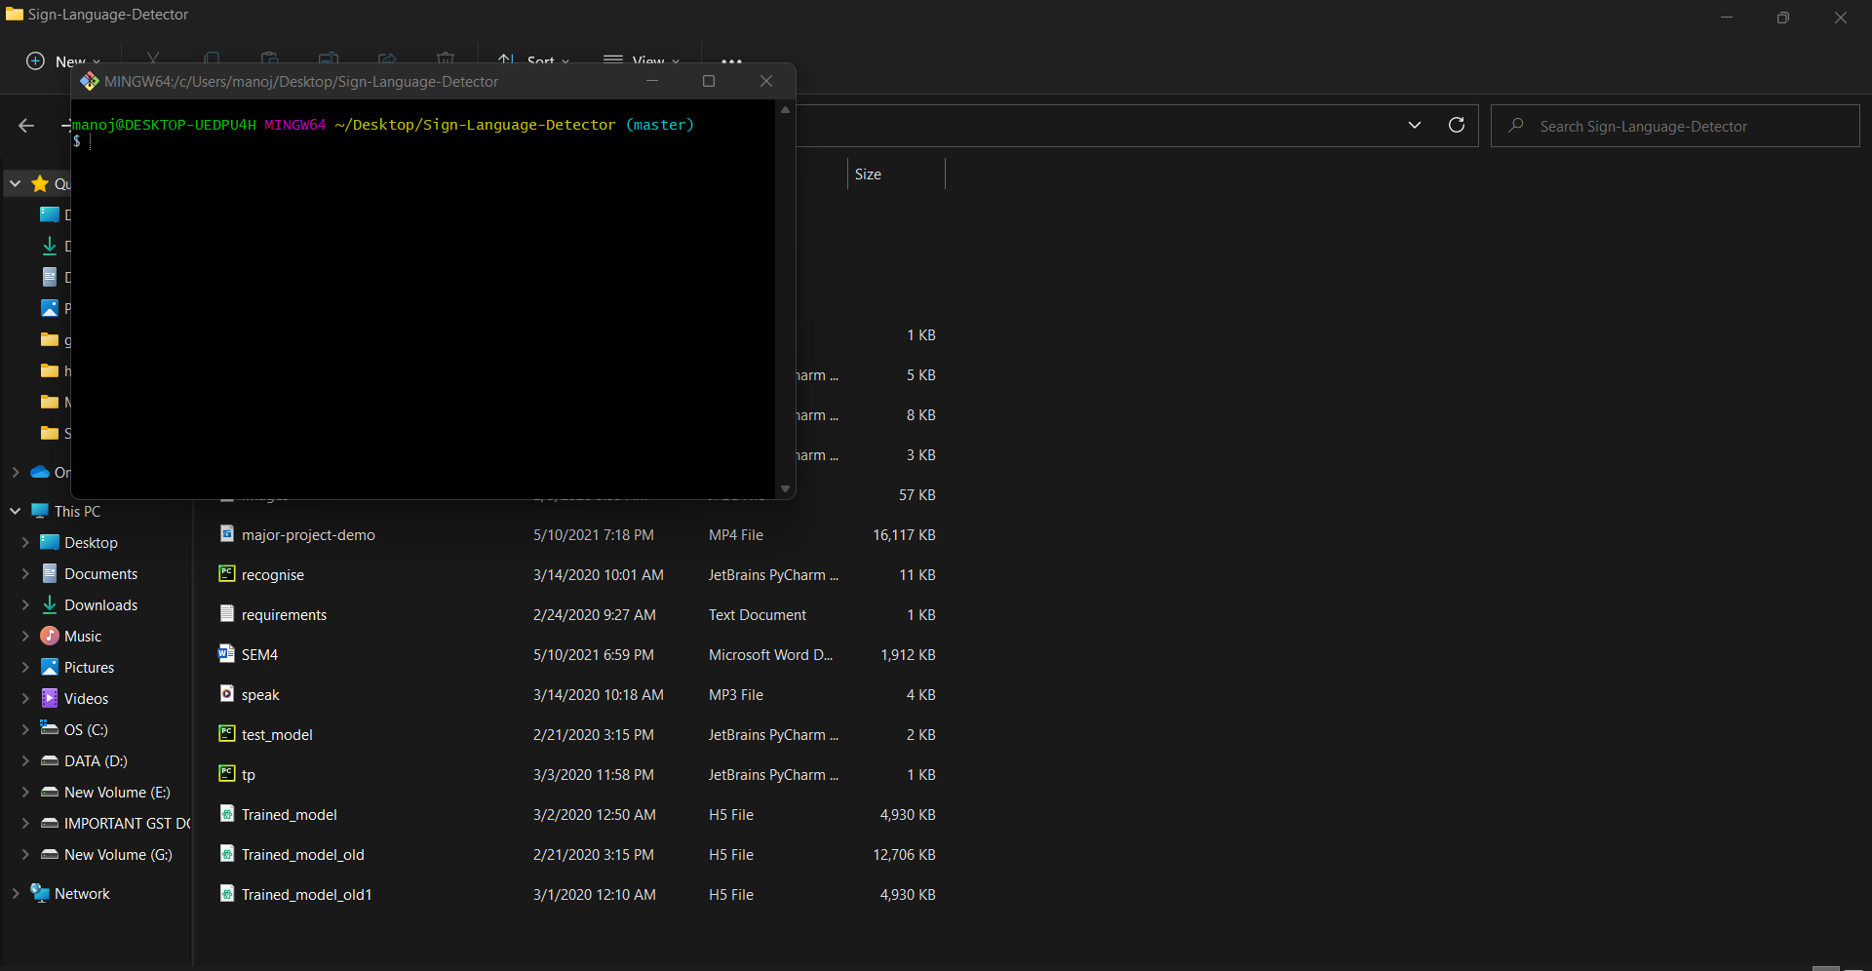

FIRST WE HAVE TO OPEN GITBASH IN THE FOLDER WERE ARE MAIN PROJECT FOLDER IS PRESENT

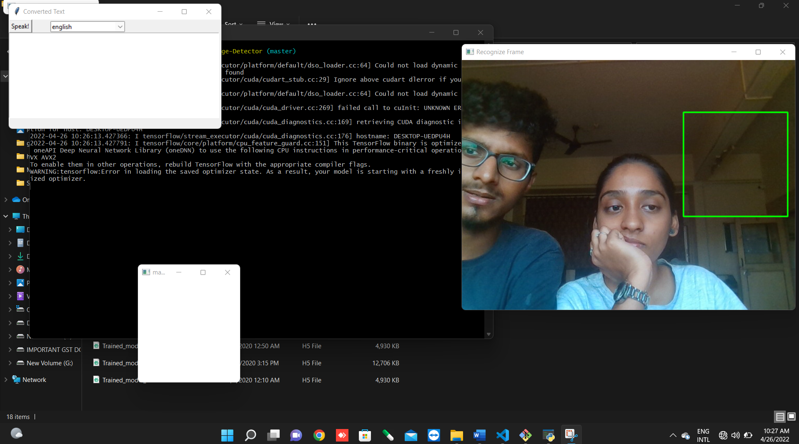

1. AFTER RUNNING COMMAND IN TERMINAL PYTHON PYTHON RECOGNISE.PY
2. IT WILL OPEN THREE WINDOWS FIRST REGONISE FRAME ,COMMAND TEXT ,AND MASK BOX
3. THERE WILL BE A GREEN BOX IN RECOGNISE FRAME THAT IS CALLED AS ROI(REGION OF INTEREST)
4. ROI WILL TAKE AN INPUT OF HAND GESTURE BY THE USER AND IT WILL DETECT IN THE MASK WINDOW AND OUTPUT MESSAGE WILL SHOWN IN THE COMMAND TEXT RESPECTIVELY.

**Model and Process Design**

Model:

**CNN**

In [deep learning](https://en.wikipedia.org/wiki/Deep_learning), a **convolutional neural network** (**CNN/ConvNet**) is a class of [deep neural networks](https://en.wikipedia.org/wiki/Deep_neural_network), most commonly applied to analyze visual imagery. Now when we think of a neural network we think about matrix multiplications but that is not the case with ConvNet. It uses a special technique called Convolution. Now in mathematics **convolution** is a mathematical operation on two functions that produces a third function that expresses how the shape of one is modified by the other.

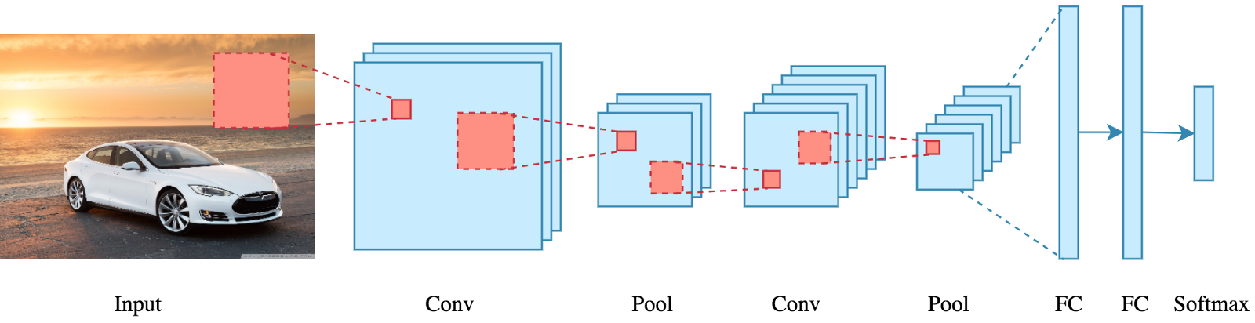

**Details of Hardware & Software**

* Software
  + PyCharm
  + VS Code
  + Git Bash Terminal
  + Tensor
  + Keras
* Hardware
  + Processor:PentiumIV
  + Webcam
  + 4 GB Ram
  + 5 GB free Hard Disk
  + Flash Light(If Required)

**Experiment and Results**

* **True Positive (TP) :** Predicted True and True in reality.
* **True Negative (TN) :** Predicted False and False in reality.
* **False Positive (FP) :** Predicted True and False in reality.
* **False Negative (FN) :** Predicted False and True in reality.
* **Accuracy :** (TP+TN)/total
* **Precision :** TP/TP+FP
* **Recall :**  TP/TP+FN

**Results**

* Recall (True Positive Rate) = 0.8084
* mAP = 0.7531
* [Loss](https://en.wikipedia.org/wiki/Loss_function) = 0.181
* Precision = 0.929

**Ethical Issues**

* This technology is one that allows a disabled community to further integrate into an abled community, and may be viewed as an assimilation and bending to the rules of a privileged community. This may reduce efforts of hearing people to accommodate for deaf people.
* The dataset needs to be diverse enough in order to accommodate people of all skin tones and in all environments. A bias in data could possibly disadvantage deaf people of a certain ethnic group.

**Conclusion and Future Work**

Our project helps people with hearing impairment to communicate in real time with people who don't know sign language in the most efficient and effective way.

|  |  |
| --- | --- |
| **Features:**   1. It works in real-time. 2. It is a web application. 3. It has a responsive UI. 4. Specific signs for special use cases like detecting weather reports. | **Limitations:**   1. It works for only 10 letters and 5 other words 2. Needs to be trained with more letters and words. 3. Dataset is not diverse enough. |

**Future Work:**

* With more amount and precise dataset we could increase its accuracy and efficiency.
* It could be scaled up to more words for better communication.
* Can be integrated with various APIs to get more information.

**References**

**Research Papers/ Journals:**

1. [J. Sun, T. Ji, S. Zhang, J. Yang and G. Ji, "Research on the Hand Gesture Recognition Based on Deep Learning," 2018 12th International Symposium on Antennas, Propagation and EM Theory (ISAPE), 2018, pp. 1-4, doi: 10.1109/ISAPE.2018.8634348](https://ieeexplore.ieee.org/document/8634348)
2. [G. Wang and X. Ma, "Traffic Police Gesture Recognition using RGB-D and Faster R-CNN," 2018 International Conference on Intelligent Informatics and Biomedical Sciences (ICIIBMS), 2018, pp. 78-81, doi: 10.1109/ICIIBMS.2018.8549975.](https://ieeexplore.ieee.org/abstract/document/8549975)
3. [Angona, Tazkia & Shaon, A. & Niloy, Kazi & Karim, Tajbia & Tasnim, Zarin & Reza, S M Salim & Mahbub, Tasmima. (2020). “Automated Bangla sign language translation system for alphabets by means of MobileNet. TELKOMNIKA (Telecommunication Computing Electronics and Control).” 18. 1292. 10.12928/telkomnika.v18i3.15311.](https://www.researchgate.net/publication/342128498_Automated_Bangla_sign_language_translation_system_for_alphabets_by_means_of_MobileNet)
4. [Deza, Anna, and Danial Hasan" MIE324 Final Report: Sign Language Recognition"](https://www.eecg.utoronto.ca/~jayar/mie324/asl.pdf)

**Weblinks:**

1. [Machine Learning](https://en.wikipedia.org/wiki/Machine_learning) accessed on 8th Sept
2. [Comparison of different models accessed](https://cv-tricks.com/object-detection/faster-r-cnn-yolo-ssd/) on 15th Sept
3. [Mobilenet SS](https://www.analyticsvidhya.com/blog/2020/04/build-your-own-object-detection-model-using-tensorflow-api/)D accessed on 22nd Sept

### 

### Annexure

### 4.1 Published Paper /Camera Ready Paper/ Business pitch/proof of concept

Since our project is a full year project we still have to work on our UI. So we are going to publish it in our next semester.